

CSE 3224

**INFORMATION SYSTEM DESIGN AND SOFTWARE ENGINEERING LAB**

ENTITY RELATIONSHIP DIAGRAM

Submitted by

**Samin Shahriar Tokey** | 14-02-04-066

**Biozid Niloy** | 14-02-04-070

**Naimul Haque** | 14-02-04-080

**Sanaul miraj** | 14-01-04-131

GREENER EARTH

A website on Climate Change

**ENTITY-RELATIONSHIP DIAGRAM (ERD)**

An entity-relationship diagram (ERD) is a data modeling technique that graphically illustrates an information system’s entities and the relationships between those entities. An ERD is a conceptual and representational model of data used to represent the entity framework infrastructure.

The elements of an ERD are:

* Entities
* Relationships
* Attributes

Uses:

* Can be used as the foundation for a relational database. Entities are the "things" for which we want to store information. An entity is a person, place, thing or event.
* Attributes are the data we want to collect for an entity.
* Relationships describe the relations between the entities.

**ENTITY SET NAMES:**

1. Threads (For creating Forums)

2. Profile (For creating a personalized account for each user)

3. Discussion (Expands under Threads, for discussing on a certain topic)

4. Ideas (Ideas on how to tackle this problem)

5. Survey (User can take a survey on climate change)

Each of the entity has its own attribute depending on its relation with other changes

**ATTRIBUTES OF EACH ENTITY:**

**Threads:**

1. heading varchar(5000)

2.headid int(11)

3. user_Id int(11)

4. date datetime

**Profile:**

1. Name varchar(500)

2. Email varchar(500)

3. Password varchar(500)

4. ConfirmPassword varchar(500)

5. Image varchar(500)

6. State varchar(500)

7. ID int(11)

8. Vision varchar(500)

9. totalDonation int(11)

**Discussion:**

1. heading varchar(5000)

2. commId int(11)

3. comment varchar(5000)

4. user_id int(11)

5 . date datetime

**Ideas:**

1. Name int(11)

2. Email varchar(50)

3. Message varchar(5000)

**Survay:**

1. Name varchar(5000)

2. Level varchar(5000)

3. global varchar(5000)

4. evidence varchar(5000)

5. activity varchar(5000)

6. environment varchar(5000)

7. steps varchar(5000)

**Here is the Entity relationship diagram with detailed attributes.**

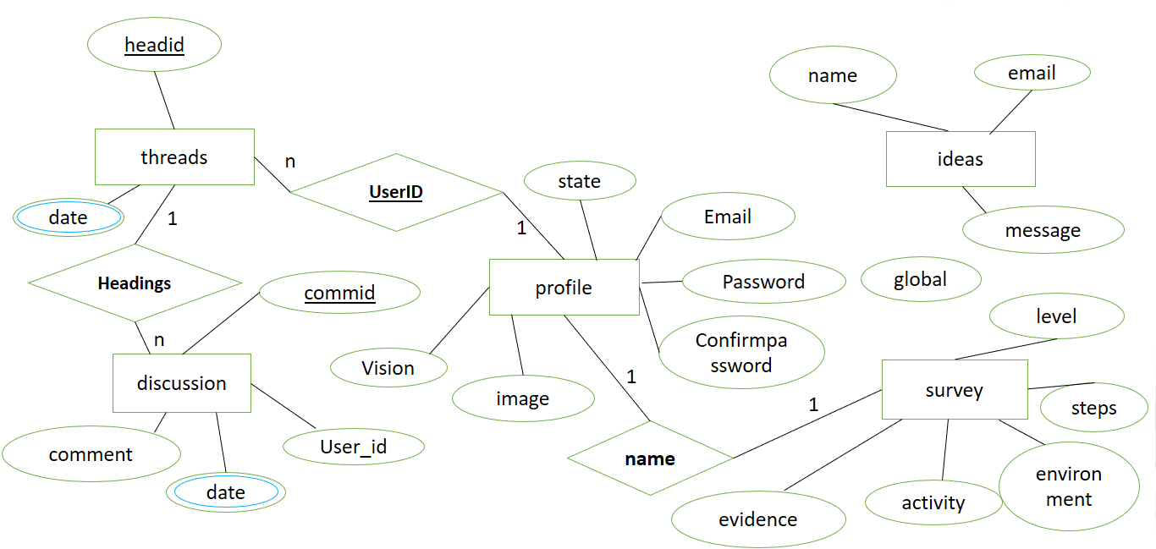

**Explanations:**

This ERD has three relations. One between Threads and Discussion. 1 Thread can have many Discussions. Another relation is between Profile and Survey. Each user can take only one survey. If he takes the survey again then his previous survey will be overwritten. The last relation is between user and Threads. 1 user can create as many threads as he wants. And can discuss through those threads.

However, Ideas is independent, it doesn’t need users to create an account or to log in.

**Conclusion:**

We will try our best to implement the project as the ERD and Class Diagram we have prepared. Hopefully we can develop a useful, user friendly system that satisfies the requirements of our client.